**Exercise for Introduction to jQuery**

**1. Console "Hello Word" in document.ready function**

**Ans :** *attached file hello.html*

Screenshot from console window:

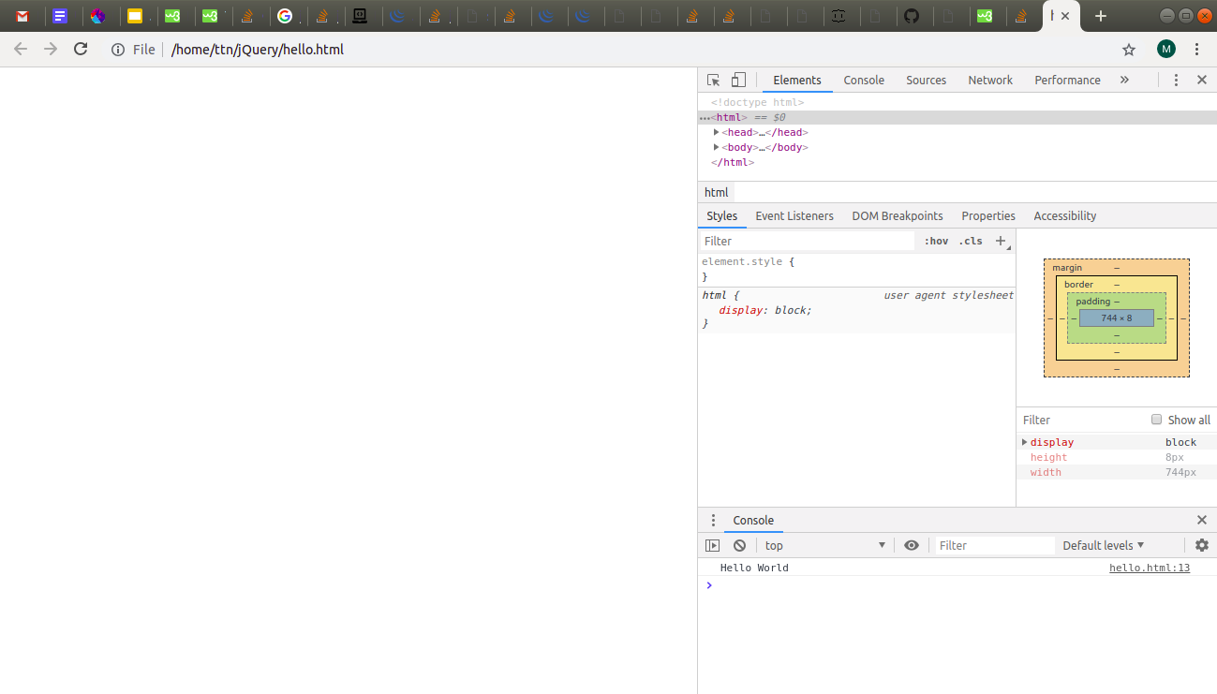

**2. Select a ID name "#test" and add class "load" when DOM is loaded**

**Ans :** *attached file addClass.html*

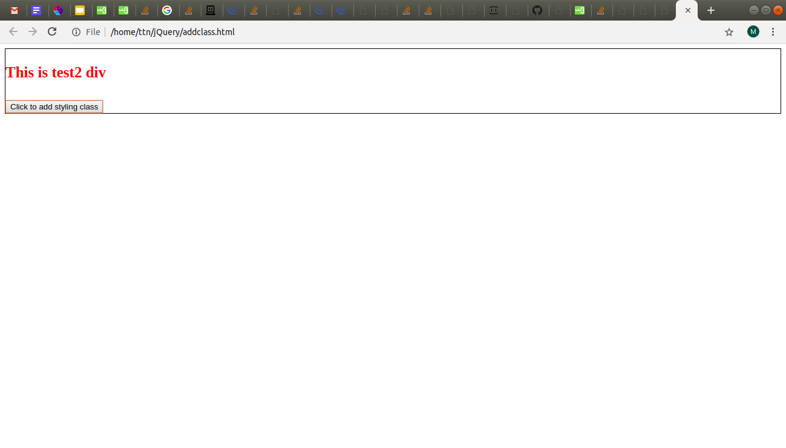

**3. Change the color of element which class name end with "-new"**

**Ans:** *attached file endswith.html*

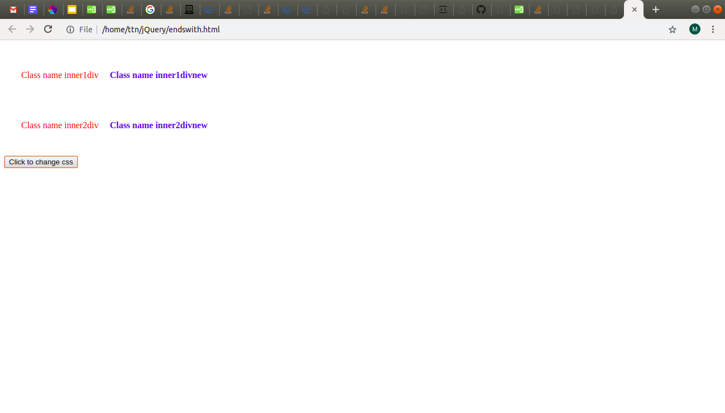

**4. Disable submit button using jquery attr method**

**Ans:** *attached file disablesubmit.html*

This is one is kind of weird, a day before it wasnt working but later found its fix which was to add disabled=”false” in input tag itself. Next day, this submit button is getting disabled by itself on page load. If i remove that disabled attribute, it wont work again, but removing this attribute and keeping rest of code same, it ran with success in other system.

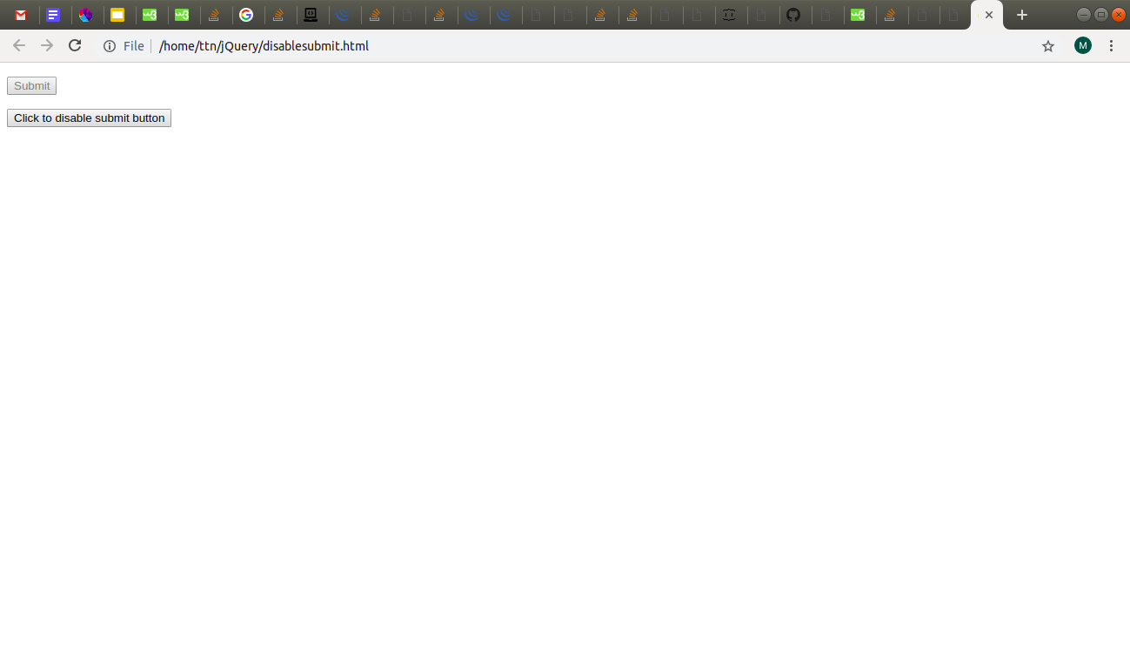

**5. Change the font size of ".target" which has parent element with id name "#main"**

**Ans:** *attached file target.html*

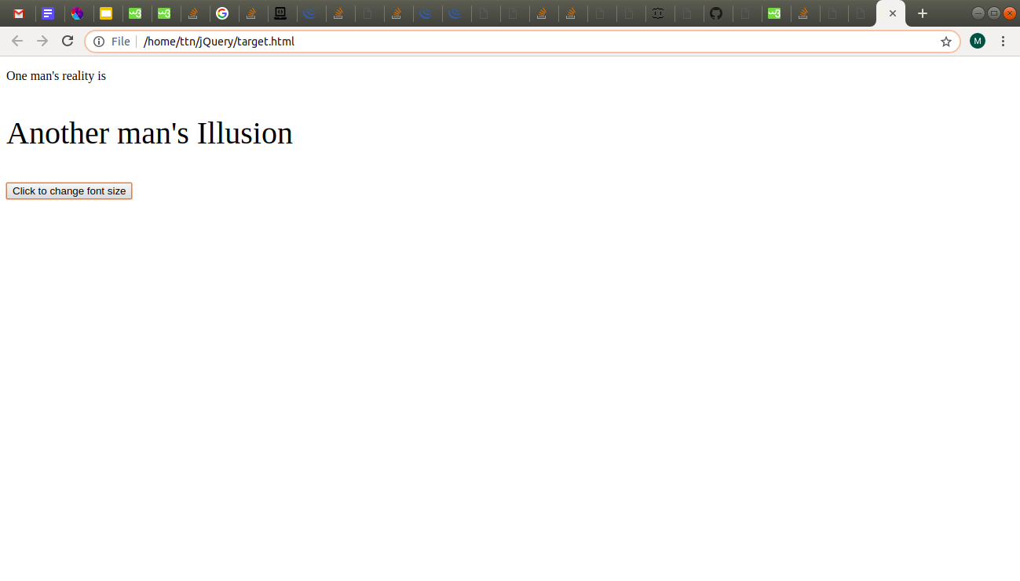

**6. After page load change the HTML of div element with "p" element**

**Ans:** *attached file replacedivcontent.html*

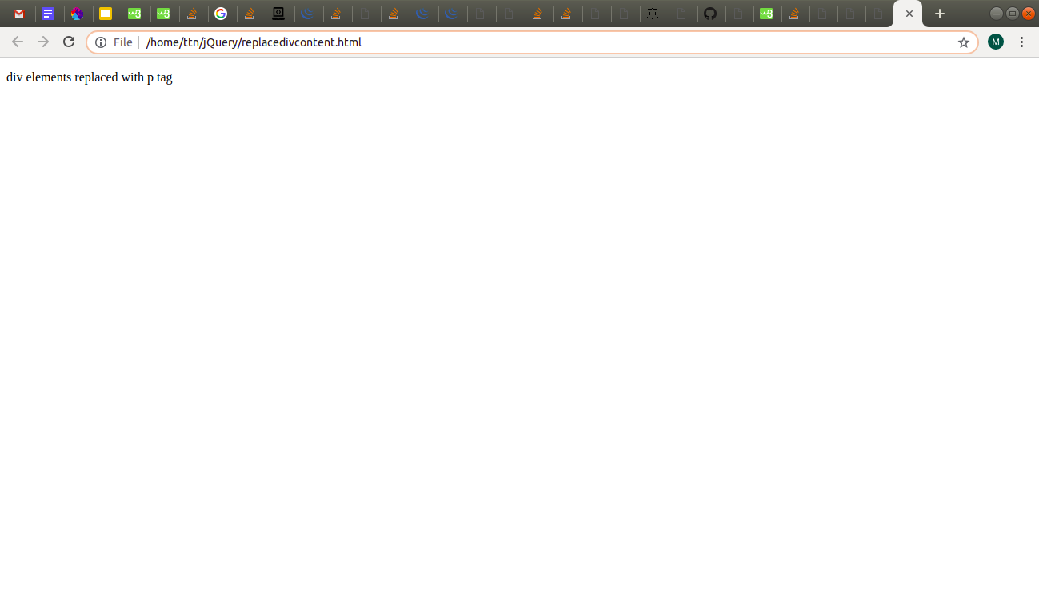

**7. Bind a click function to an "click" element and append next "click" next to it.**

**Ans : answered in ques 8.**

**8. Click event not working on element which added dynamicly or via script, make it work using .on method**

**Ans:** Questions 7 & 8th combined here. In our doubt session, after a lot of debates/discussion on these 2 questions, we all came to conclusion that these 2 questions are linked.

For 7th question, clicking on main button adds sub buttons that looks like “button 0 main”

For 8th, Each new button shows its button number and id of parent button it came from

Example: “Button 0 from main” is a new button created from id”main” button.

“Button 7 from button 4” is a new button that came by clicking id=”button 4”

New button ids are generated and assigned dynamically.

on(click) even was also used.

*Attached file seventh.html*

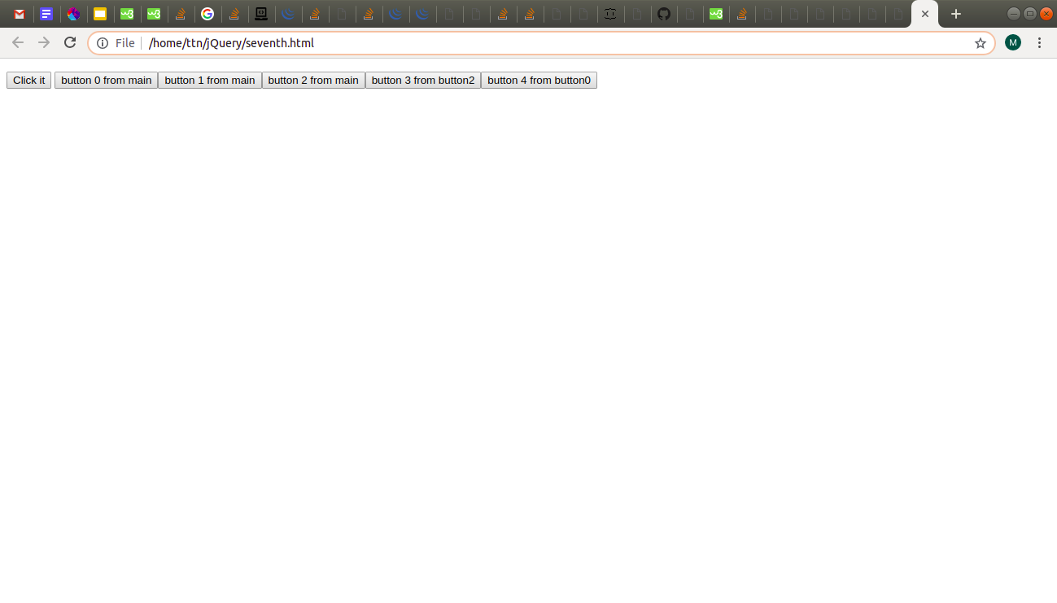

**9. Get dropdown selected value on onchanage event and append in div container**

**Ans:** *attached file onchange.html*

.each function also had to be used to look for each selected option

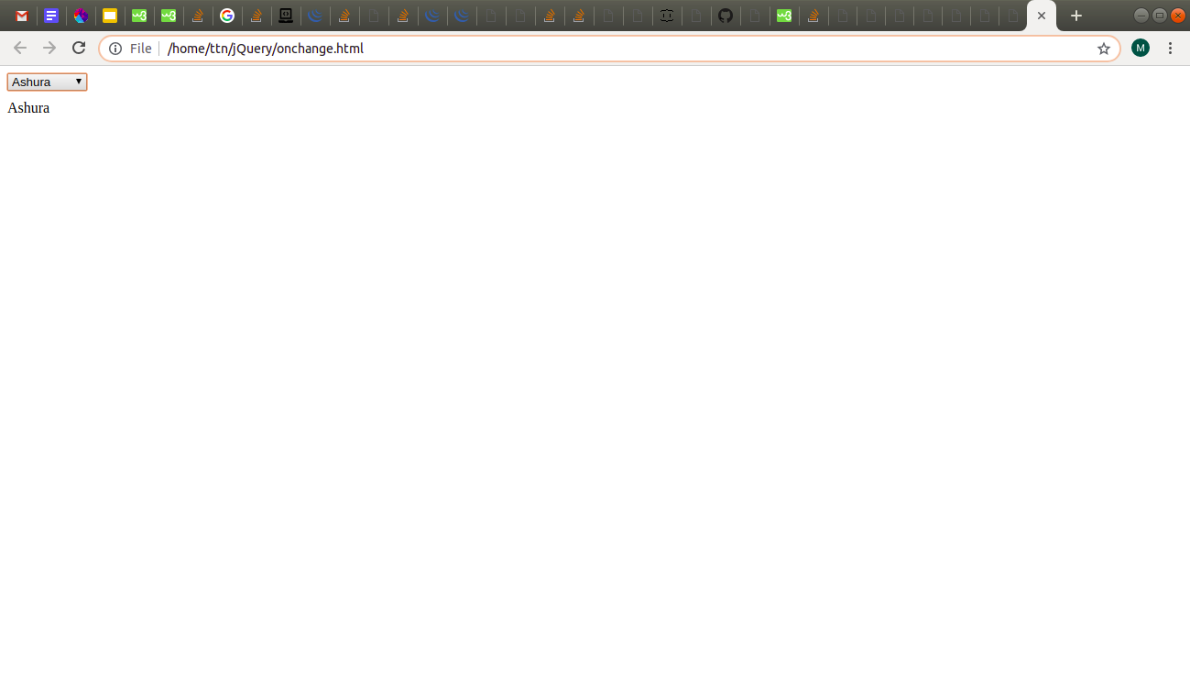

**11. On clicking on "google" tag. It is taking us to google home page. Stop it from happening.**

**Ans:** *attached file preventdefault.html*

Preventdefault function was used on anchor tag

Its working is best viewed in its file itself, hence no screenshot.

**12. We have bind a click funtion to parent div but we want stop it from performing when user clicks on its child li**

**Ans:** on click function with parameter ‘e’, i have used if(e.target!=this) return, which says that if click target is on any other container/element but current div itself, then it would simply return even if the target is made on its child.

*Attached file preventparent.html*

Its working is best viewed in its file itself, hence no screenshot.

**13. Get the max height of elements using jquery each method**

**Ans:** 4 divs created, all with different height and differnet border colours so that they can be seen. Output returned through alert box;

*Attached file maxheight.html*

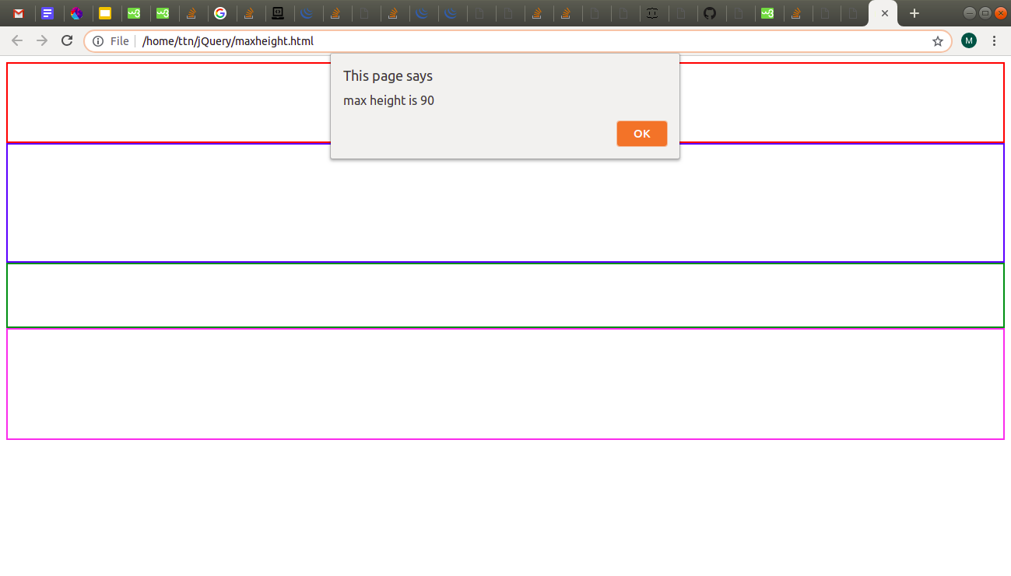

**14. Change color of every cell which has number larger than 10.**

**Ans:** cells with text > 10 has been given unique ids dynamically and their css is modified.

*Attached file cell.html*

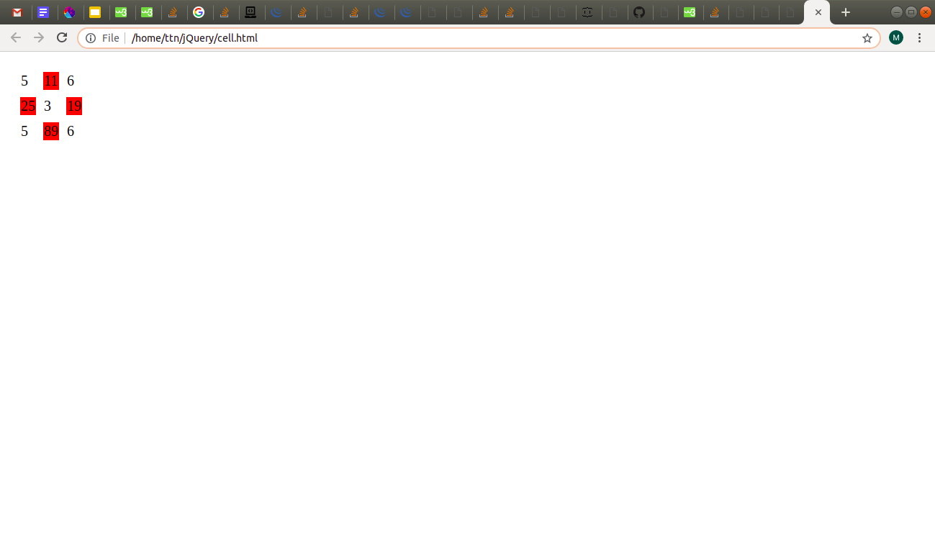

**15. Retrive the data from server using ajax get call**

**Ans:** JSON placeholders were used here which contain fake API, from where we can apply methods like GET,POST,PUT,DELETE.

Output shown in console

*Attached file ajaxget.html*

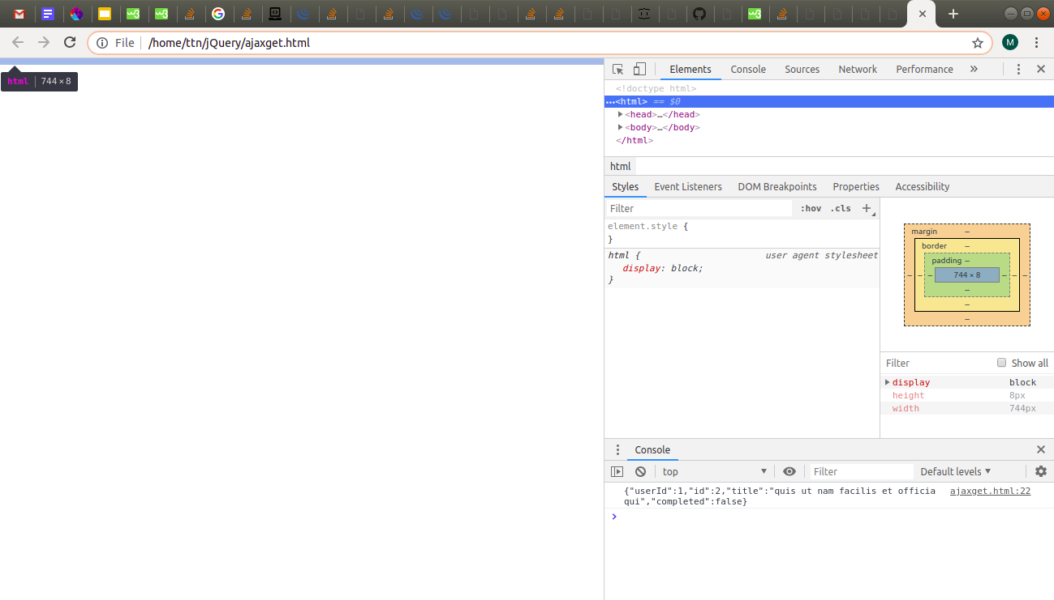

**16. Add cross button on row and bind click function which make a delete request to server, after success event remove the row from dom**

**Ans:** for this question, i have used GET method in table only for 1 data. For a N size array of data**,** dynamic table rows and columns could be created and inside ajax a loop would be used for like i <data.length().

Later, ajax DELETE method is used on cross button.

*Attached file ajaxdelete.html*

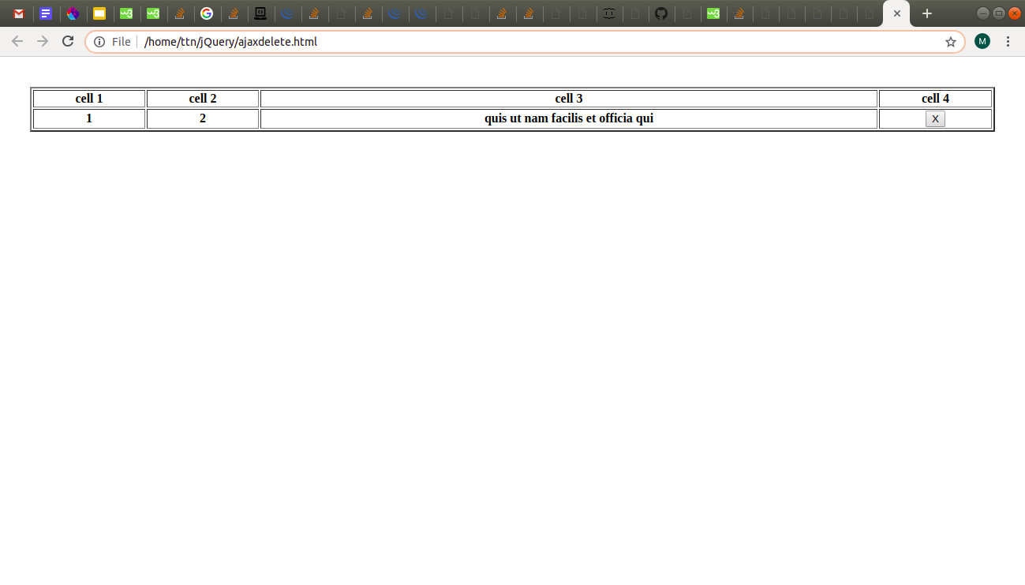

**17. Create a image array and in div create a slide show to animate images of delay of 500ms.**

**Ans :** this question is troublesome. I understood how it can be done is javascript but for jquery, i couldnt find setTimeOut or setInterval methods of javascript in jquery version.